Module | WSQ- Business Analytics (SF)
Name | Koh Chun Yao
Date | 11 Feb 2026

Assignment-1b Submission

Task 1 - GET DATA FROM A SQL SERVER

Provide screenshot of list of Queries in Power Query Editor when load data from SQL server

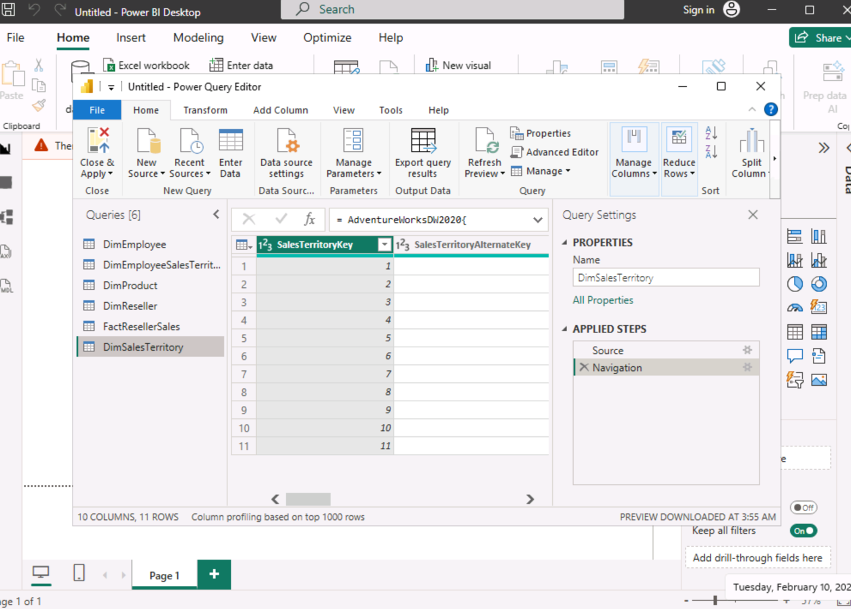

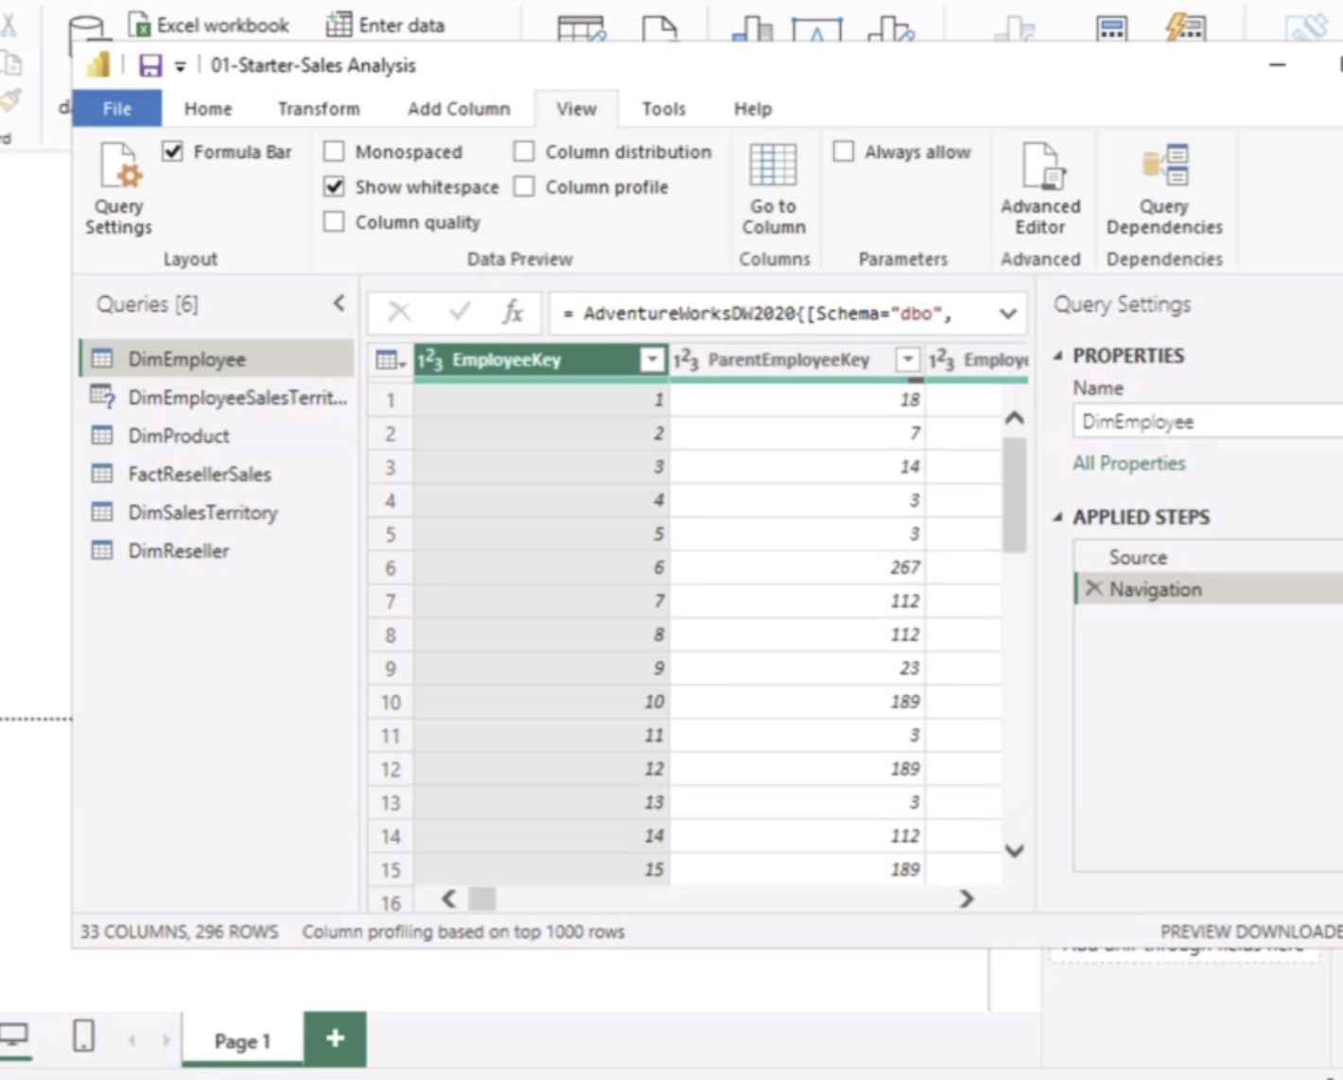

Task 2 - GET DATA FROM A CSV FILE

Provide screenshot of list of updated Queries in Power Query Editor when load data from CSV file

